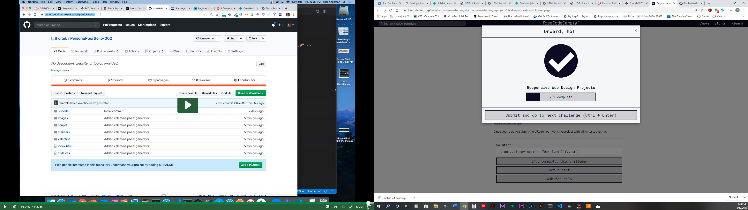

<https://sleepy-noether-70c4bf.netlify.com>

<https://github.com/BobbyWasabi/Personal-Portfolio>

<https://sleepy-noether-70c4bf.netlify.com/#projects>